Monday
Objective(s): I will be able to identify and make use of subject-verb agreement in writing.

We have been learning verb tenses for a few weeks now, and we know that a verb shows an action in a sentence. In a sentence, every verb must have a subject. If the verb expresses action—like sneeze, jump, bark, or study—the subject is who or what does the verb. Take a look at this example:

During his biology lab, Tommy danced on the table.

Danced is an action verb. Tommy is who did the dancing. Look at the next example:

The speeding hotrod crashed into a telephone pole.

Crashed is the action verb. The hotrod is what did the crashing.

Not all verbs are action verbs. Some verbs are linking: am, is, are, was, were, seem, and become, among others. Linking verbs connect the subject to something that is said about the subject. Take a look at this example:

Ron's bathroom is a disaster.

Bathroom is the subject. Is connects the subject to something that is said about it, that the bathroom is a disaster. Here is another example:

The bathroom tiles are fuzzy with mold.

The word tiles is the subject. Are connects tiles to something said about them, that they are fuzzy with mold.
Generally, but not always, the subject of a linking verb will come before the linking verb.

A singular subject demands a singular verb; a plural subject demands a plural verb. That is the simple principle behind subject-verb agreement. Remember that singular verbs usually end in s, but plural verbs usually do not. Watch the video https://youtu.be/37XBATSQm8U to see more example with singular and plural subjects and verbs.

Examples:
Singular: A teacher helps. A student asks. A magazine article informs.
Plural: Teachers help. Students ask. Magazine articles inform.
Practice:
My __________ decorate the house for every holiday. (mother, sisters)

My friends ________ that it’s great. (thinks, realize)

My ___________ _________ strings of colorful lights around the window.
(brother, brothers) (hang, hangs)

What If…. Sentences with Compound Subjects
A compound subject has two or more simple subjects joined by a conjunction (and, or). Listed below are the two main rules for subject-verb agreement in sentences with compound subjects.

Rule 1: When a sentence has a compound subject connected by and, the verb should be plural. Example: Baseball and tennis are my favorite sports.

Rule 2: When a sentence has a compound subject connected by or, the verb should agree with the subject closest to it. Example: Josh or my other friends usually shoot hoops in the part.

Subject and Verb Agreement Exercise
Choose the correct form of the verb that agrees with the subject.
1. Annie and her brothers (is, are) at school.
2. Either my mother or my father (is, are) coming to the meeting.
3. The dog or the cats (is, are) outside.
4. Either my shoes or your coat (is, are) always on the floor.
5. George and Tamara (doesn't, don't) want to see that movie.
6. Benito (doesn't, don't) know the answer.
7. One of my sisters (is, are) going on a trip to France.
8. The man with all the birds (live, lives) on my street.
9. The movie, including all the previews, (take, takes) about two hours to watch.
10. The players, as well as the captain, (want, wants) to win.
11. Either answer (is, are) acceptable.
12. Every one of those books (is, are) fiction.
13. Nobody (know, knows) the trouble I've seen.
14. (Is, Are) the news on at five or six?
15. Mathematics (is, are) John's favorite subject, while Civics (is, are) Andrea's favorite subject.
16. Eight dollars (is, are) the price of a movie these days.
17. (Is, Are) the tweezers in this drawer?
18. Your pants (is, are) at the cleaner's.
19. There (was, were) fifteen candies in that bag. Now there (is, are) only one left!
20. The committee (debates, debate) these questions carefully.
21. The committee members (leads, lead) very different lives in private.
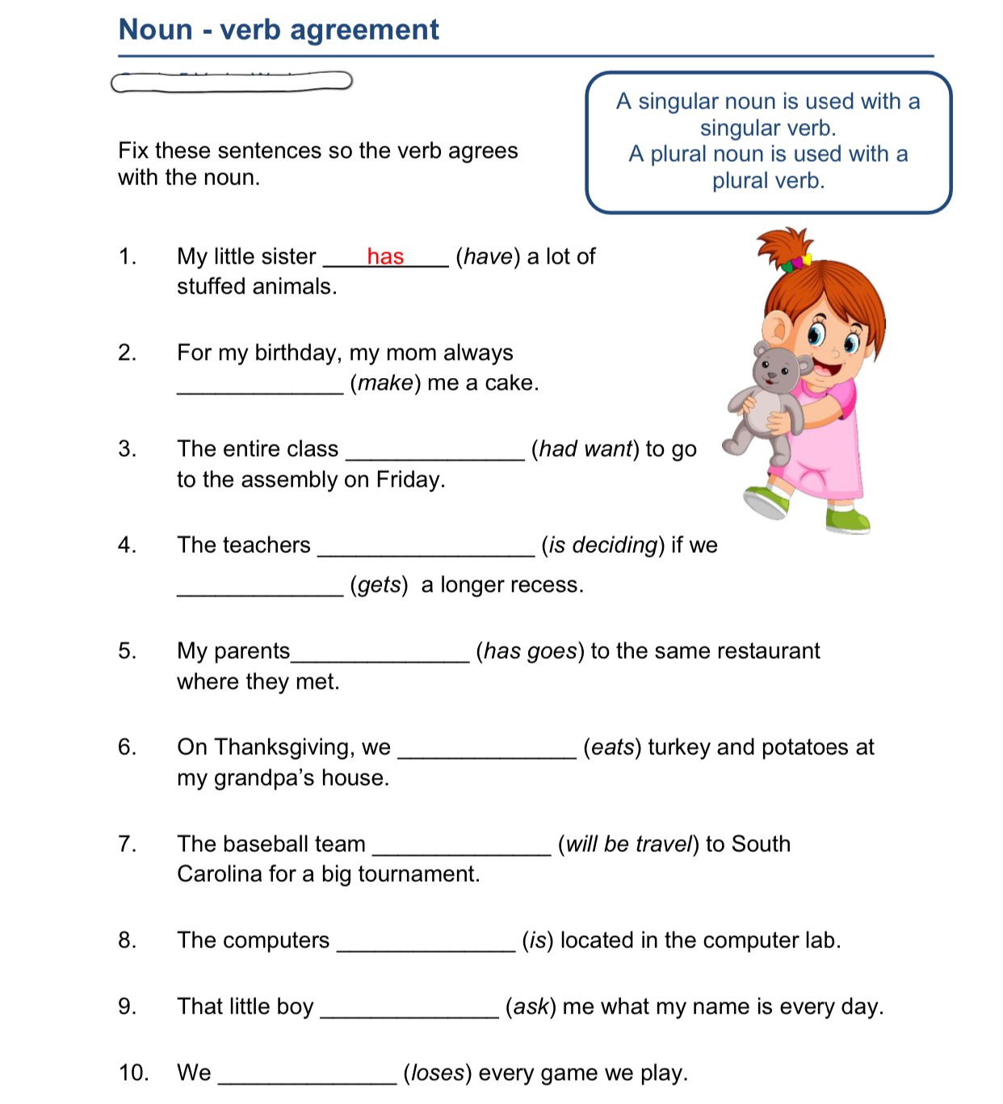
22. The Prime Minister, together with his wife, (greets, greet) the press cordially.
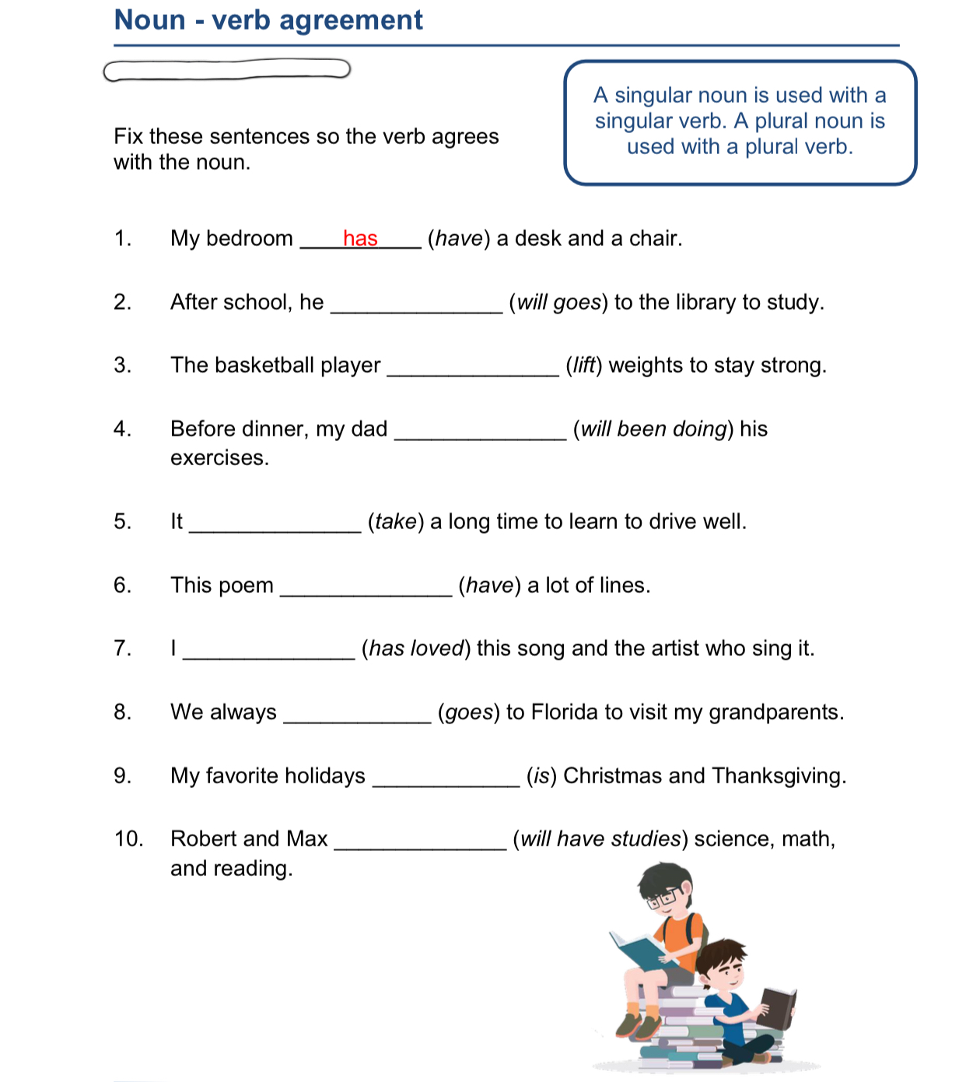

Tuesday
Objective(s): I will be able to identify simile, metaphor, imagery, and motif used in a poem.
A few weeks ago, we learned about the figurative language we see in poems. Today, we are going to keep working on figurative language used in poems. More specifically, simile and metaphor.
Figurative language is used to describe and imply ideas indirectly. The expressions used are not literally true, but express truth beyond the literal level. Figurative language appears most often in poetry.
Recall the two main types of figurative language are simile and metaphor. A simile is a comparison using the words like or as. A metaphor is a direct comparison.

Simile examples
The metal twisted like a ribbon
She is as sweet as candy.
However, using “like” or “as” doesn’t make a simile. A comparison must be made.
Not a Simile: I like pizza.
Simile: The moon is like a pizza.

Metaphor examples
All the world is a stage.
Men are dogs.
She has a stone heart.
DIRECTIONS: Read the poem “Hockey” by Scott Blaine. As you read, notice the comparisons he uses to describe what it is like to play hockey. Answer the questions that follow.
Hockey
by Scott Blaine

The ice is smooth, smooth, smooth.
The air bites to the center
Of warmth and flesh, and I whirl.
It begins in a game...
The puck swims, skims, veers,
Goes leading my vision
Beyond the chasing reach of my stick.

The air is sharp, steel-sharp.
I suck needles of breathing,
And feel the players converge.
It grows to a science...
We clot, break, drive,
Electrons in motion
In the magnetic pull of the puck.

The play is fast, fierce, tense.
Sticks click and snap like teeth
Of wolves on the scent of a prey.
It ends in the kill...
I am one of the pack in a mad,
Taut leap of desperation
In the wild, slashing drive for the goal.

1. Identify two metaphors in the first stanza and one simile in the third stanza. For each example of figurative language, explain the two concepts that are being compared.

2. Out of all the figurative language in this poem, which comparison do you like most or find most effective? Identify this phrase and explain why you like it.

3. What is the main idea of this poem? How does the figurative language help convey it? Explain.

Now let’s talk about imagery and motif. Imagery refers to words and phrases that create a picture that appeals to one or more of the reader’s senses.
Examples of imagery
It was dark and dim in the forest.
The words “dark” and “dim” are visual images.
The children were screaming and shouting in the fields.
“Screaming” and “shouting” appeal to our sense of hearing, or auditory sense.
He whiffed the aroma of brewed coffee.
“Whiff” and “aroma” evoke our sense of smell, or olfactory sense.
The girl ran her hands on a soft satin fabric.
The idea of “soft” in this example appeals to our sense of touch, or tactile sense.
The fresh and juicy orange is very cold and sweet.
“Juicy” and “sweet” – when associated with oranges – have an effect on our sense of taste, or gustatory sense.
A motif is a recurring idea, image, or group of images that contributes toward the development of the literature. It can be confusing when we look at the theme and the motif together because they are similar. This video https://youtu.be/FQqPyC6o3JQ will help you to understand the difference better.

Motif examples in literature
The Great Gatsby by F. Scott Fitzgerald
Story: In the summer of 1922, a rich man tries extravagantly to win the girl of his dreams.
Motifs: Wealth and finance (the corruption of the American Dream), time and clocks (our relationship with the past and future)

Lord of the Flies by William Golding
Story: After a plane crashes, a band of boys must survive on a deserted island.
Motifs: Fire (connection to technology and civilization), religious allegory (moral truth)

Hamlet by William Shakespeare
Story: Tormented by grief, a young man hunts for the truth to avenge his dead father.
Motifs: Ears (the unreliability of truth), birth and death (ephemerality of existence)
DIRECTIONS: Read the poem “Velvet Shoes” by Elinor Wylie. As you read, try to identify the imagery and motif of this poem. Then answer the questions on the following page.
Velvet Shoes
by Elinor Wylie

Let us walk in the white snow
In soundless space;
With footsteps quiet and slow,
At a tranquil pace,
Under veils of white lace.

I shall go shod in silk,
And you in wool,
White as a white cow’s milk,
More beautiful
Than the breast of a gull.

We shall walk through the still town
In a windless peace;
We shall step upon white down,
Upon silver fleece,
Upon softer than these.

We shall walk in velvet shoes:
Wherever we go
Silence will fall like dews
On white silence below.
We shall walk in the snow.

1. Identify four examples of visual imagery in the poem.

2. Based on these images listed in question 1, what is the dominant motif of the poem? In other words, what do all these images have in common?

3. What do you think the author’s purpose was in writing this poem? How does the dominant motif of the poem achieve this purpose?

Wednesday
Objective(s): I will be able to identify and make use of consistent verb tenses in writing.
For the past few weeks, we reviewed the simple, perfect, and progressive verb tenses. Following is a quick review.
Simple Tense
- refers to specific time period during which
something happens
OR
something happened and is over
OR
something will happen
Simple present (action goes on now): I sit
Simple past: (action happened and is over): I sat
Simple future (action will happen): I will sit

Perfect Tense
- uses have, has, or had as auxiliary verb
- allows action to continue over time
Present perfect (action happened and may still be going on): I have sat
Past perfect (action happened before something happened in the past): I had sat
Future perfect (action will be considered in the future, by which time it will have already happened): I will have sat

Progressive Tense
- uses is, are, was, or were as auxiliary verb with -ing ending on main verb
- focuses on “progress” of action
Present progressive (action is in progress right now): I am sitting
Past: progressive (action was in progress in the past): I was sitting
Future progressive (action will be in progress in the future): I will be sitting

Today, we are going to learn about verb tense consistency.

Verb tense consistency
Verb tense consistency refers to keeping the same tense throughout a clause. We don’t want to have one time period being described in two different tenses. If you have two or more time periods, start a new clause or a new sentence. Take this sentence with problematic tense consistency, for example:
Mark finished his essay, cleans his room, and went out for dinner.
Finished and went are in the past tense but cleans is in the present tense. Mark’s actions shift from the past to the present and back again, which is not logical. We could fix this in a couple of different ways, for example:
Mark finished his essay, cleaned his room, and went out for dinner.

Watch the video https://youtu.be/RVYqUJe-K2w to see some examples of verb tense consistency in writing.

Keeping tenses consistent
Do not shift tenses unnecessarily. If you begin writing a paper in the present tense, do not shift suddenly to the past. If you begin in the past, do not shift without reason to the present. Notice the inconsistent verb tenses in the following selection:
As a teacher, I knew that Jaime could not learn with hunger foremost in his mind. For him, the purpose of school is not only to learn the three Rs of reading, writing, and arithmetic, but it was also to serve as a social function. Since Jaime was an only child, he is also starved for interaction with other children his age.

The verbs must be consistently in the present tense:
As a teacher, I know that Jaime can not learn with hunger foremost in his mind. For him, the purpose of school is not only to learn the three Rs of reading, writing, and arithmetic, but it is also to serve as a social function. Since Jaime is an only child, he is also starved for interaction with other children his age.

Or the verbs must be consistently in the past tense:
As a teacher, I knew that Jaime could not learn with hunger foremost in his mind. For him, the purpose of school was not only to learn the three Rs of reading, writing, and arithmetic, but it was also to serve as a social function. Since Jaime was an only child, he was also starved for interaction with other children his age.

Practice
In each item below, one verb must be changed so that it agrees in tense with the other verbs. Highlight the incorrect verb and write the correct verb tense form on the blank line provided.

Example: In recent years, many individuals who took advantage of what their schools had to offer and went on to obtain good positions with established companies find themselves out of jobs. __Found__

1. Opponents of the functionalist view stress that we do not live in a static society and, thus, there were no guarantees of job security. ___________

2. Thus, the capitalists, who owned businesses and industry, are opposed by the working class, which provides the labor needed to make the products and provides the services offered by the businesses and industries. ___________

3. Marx advocated in his work The Communist Manifesto (1848) that the working class is suppressed by capitalists, who readily took advantage of them. ___________

4. School provides an efficient means of formally educating the young. While children learn from members of their immediate families, school as an institution provided a more uniform, balanced, and shared curriculum. ___________

5. Each school has a curriculum, a program that indicated what material teachers will cover. Each teacher is expected to follow the curriculum and facilitate the learning process for students. ___________

6. Some parents become very sensitive about what is in the local school curriculum or believed that the school provides an inadequate education for their child. ___________

7. There are more private K-8 schools than there are private schools for grades 9-12, so many students who attend private grade school went on to attend a public high school. ___________

8. By working with children when they are young and formable, religious leaders believe that their beliefs were more apt to be instilled in them for a lifetime. ___________

9. Another criticism is that private high schools recruited outstanding athletes from outside of their immediate area and place them on scholarships so that they avoid paying tuition to attend. ___________

10. Many homeschooled children enter either a private or a public school when they are of upper elementary or junior high/middle school age because the subject matter they need became increasingly difficult for their parents to teach them. ___________

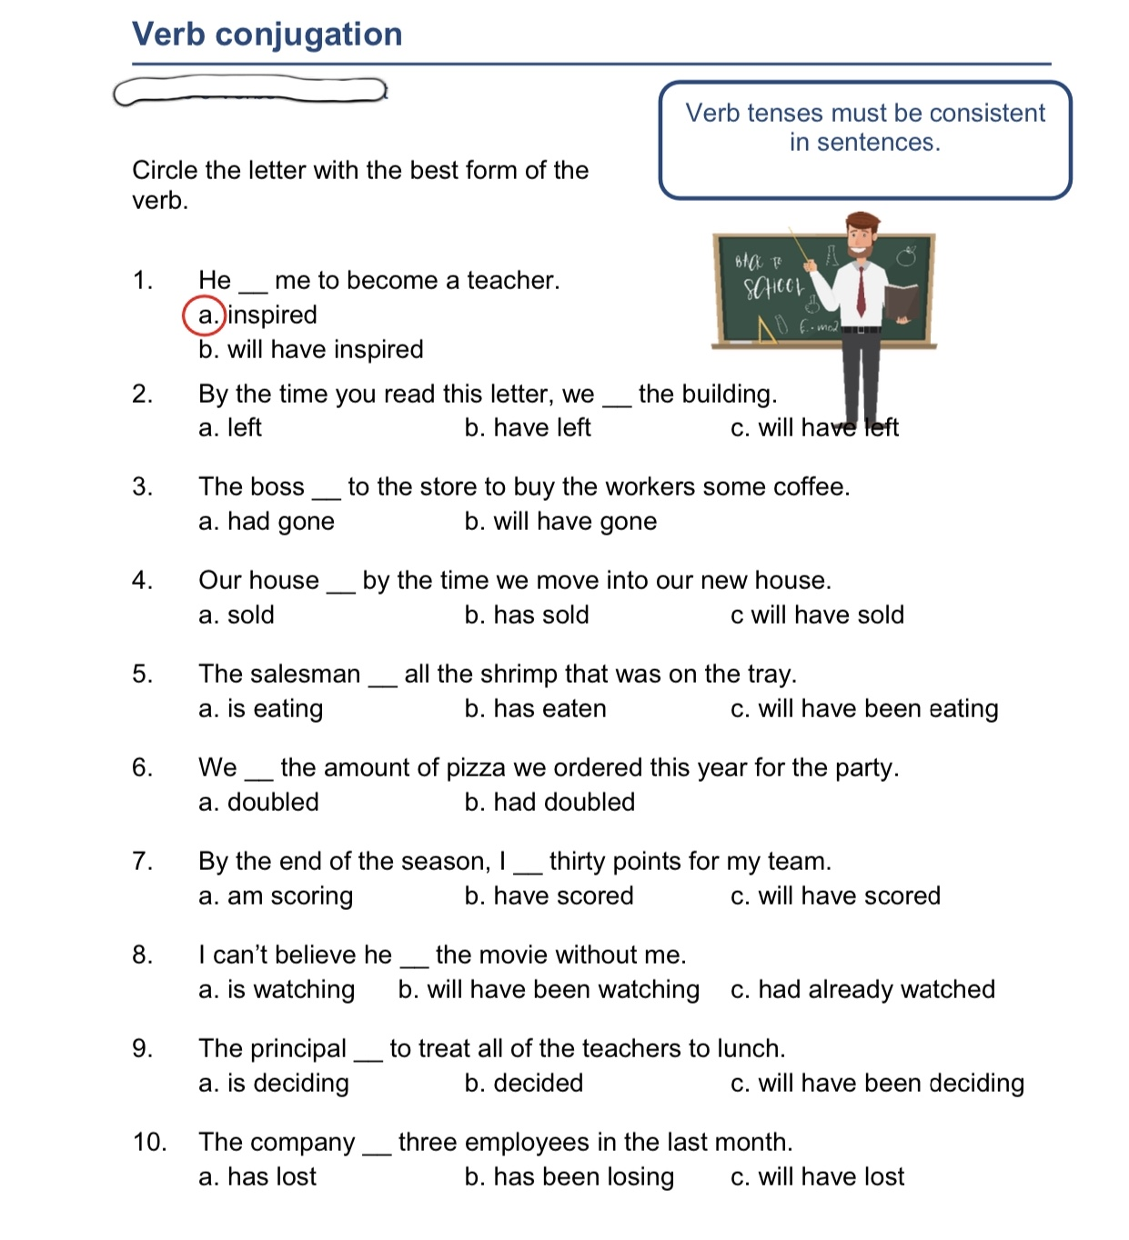
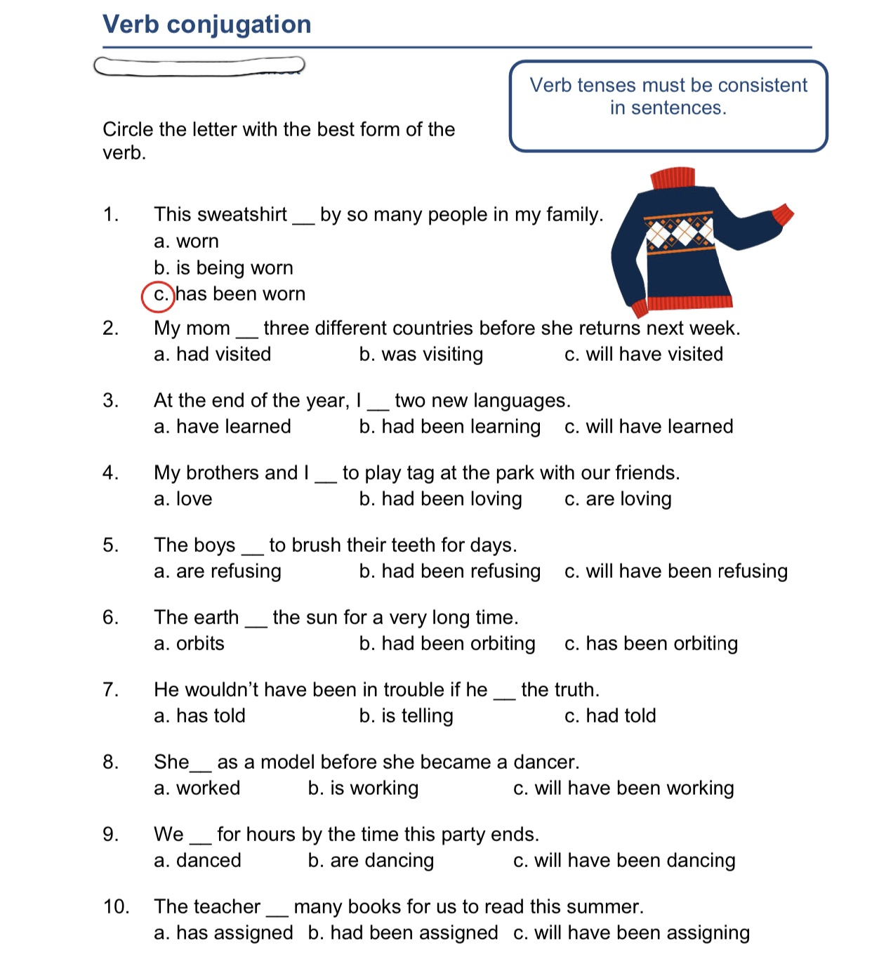
Thursday
Objective(s): I will be able to identify personification and mood in literatures.

Today we’re going to keep looking at literary devices in literatures. The first literary device we’re going to look at is personification. Personification is a literary technique that gives human qualities to animals, objects, elements of nature, or anything that is not human. Often, personification helps the reader identify with the nonhuman characters in a story or poem. Here’s a cute little song https://youtu.be/VqBZMR83wCg to help you remember the definition of personification.

Examples of Personification
Lightning danced across the sky.
The wind howled in the night.
The car complained as the key was roughly turned in its ignition.
Rita heard the last piece of pie calling her name.
My alarm clock yells at me to get out of bed every morning.
The avalanche devoured anything standing in its way.
DIRECTIONS: Read the poem “Lost” by Carl Sandburg and answer the questions on the next page. As you read, try to identify what is being personified in the poem.
Lost
by Carl Sandburg

Desolate and lone
All night long on the lake
Where fog trails and mist creeps,
The whistle of a boat
Calls and cries unendingly,
Like some lost child
In tears and trouble
Hunting the harbor’s breast
And the harbor’s eyes.

1. The author makes a comparison in this poem. Identify this comparison and explain what specific objects are personified.

2. What specific human characteristics are attributed to these objects? In your answer, refer to lines from the poem.

3. Why do you think the poet has chosen to describe these objects in such a way? What larger idea or mood does the poet convey through this description? Explain.

Friday
Objective(s): I will be able to write a hyperbole and distinguish hyperbole from other literary terms.

Today, we are going to learn a new literary device called hyperbole. I'm sure we all have used hyperbole before. A hyperbole is an exaggerated statement that is not meant to be taken literally.
Example: Keith has a ton of homework tonight.
Of course, if Keith put his homework on a scale and weighed it, it wouldn't really weigh a ton (2,000 pounds). This sentence is an exaggeration that shows he has lots of homework.

Which one is hyperbole?
- I waited a long time to be picked up from school.
- I waited an eternity to be picked up from school.
- Waiting is as boring as a speech.

The second sentence was an exaggeration. Someone can’t “wait an eternity.” This is an exaggeration.
We use hyperbole widely in our everyday speech, as we can see in the examples above. This video https://youtu.be/kuzWLDWm6Zs shows you more examples of how we use hyperboles in our everyday lives. But, hyperbole has also long been an important staple of literary prose, creative nonfiction, essays, songs, poetry, and dramatic writing too. Given its non-literal nature, we don’t often find hyperbole used in technical writing where the main focus is on clear expression devoid of emotional content.
Now let’s practice!

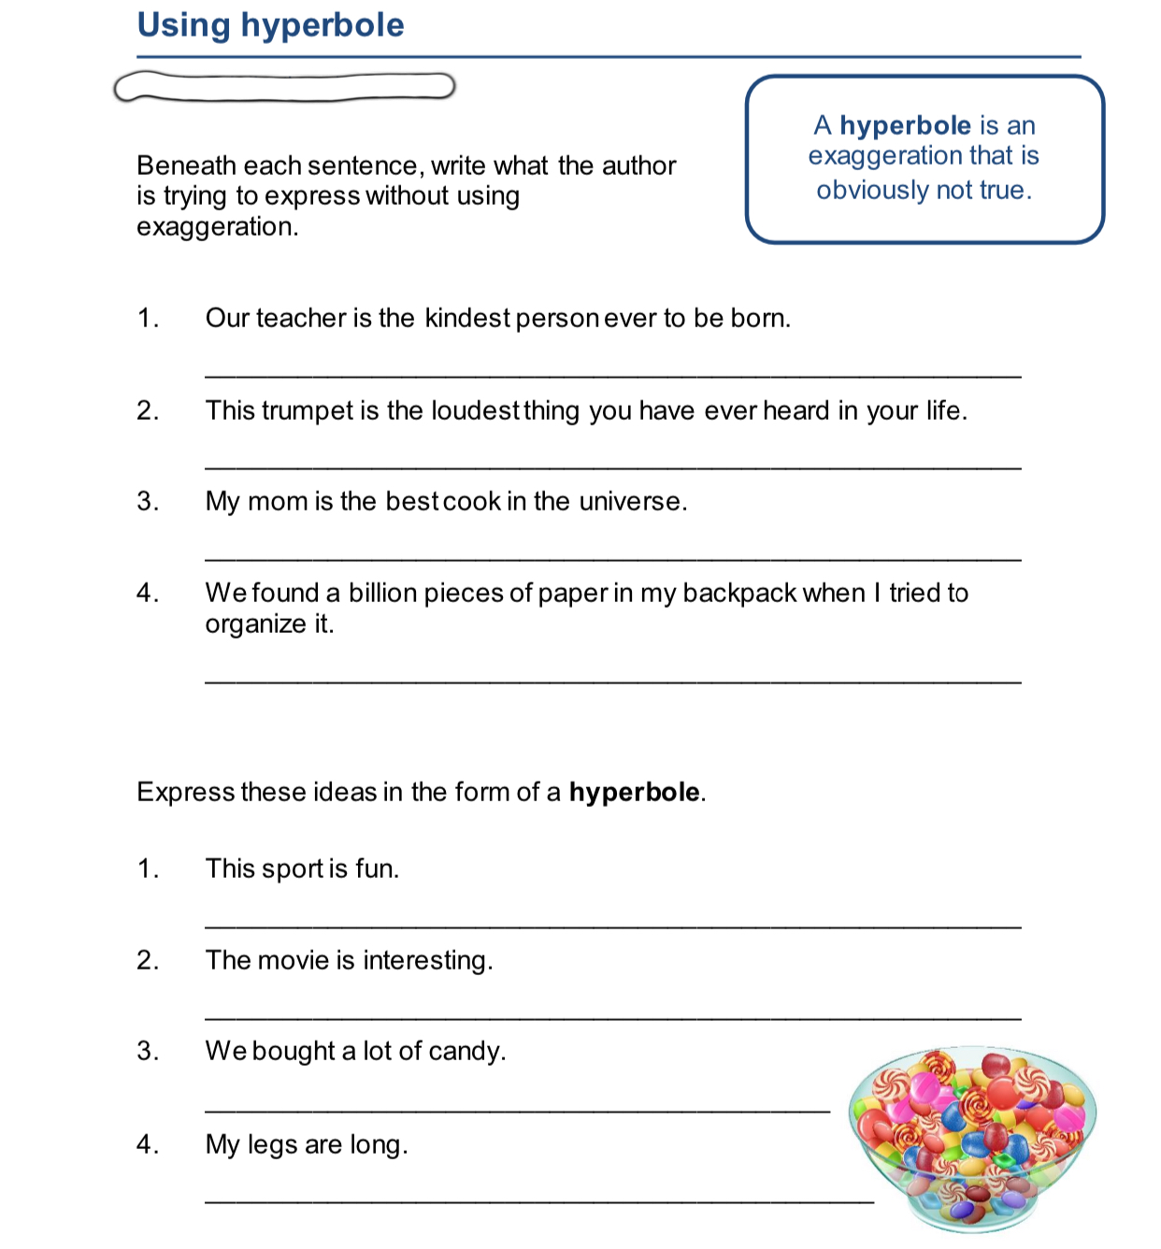

From The Grave
By Robert Blair

Dull Grave!—thou spoil'st the dance of youthful blood,
Strik'st out the dimple from the cheek of mirth,
And every smirking feature from the face;
Branding our laughter with the name of madness.
Where are the jesters now? the men of health
Complexionally pleasant? Where the droll,
Whose every look and gesture was a joke
To clapping theatres and shouting crowds,
And made even thick-lipp'd musing Melancholy
To gather up her face into a smile
Before she was aware? Ah! sullen now,
And dumb as the green turf that covers them.

Directions: Respond to these questions to the best of your ability. Answer the questions completely.

1. Identify two examples of personification: explain what is being personified & how in each example.

2. Identify an example of hyperbole: explain how it is exaggerated.

3. Identify an example of metaphor: explain which two things are being compared.

4. Identify and example of simile: explain which two things are being compared.

